**Microprocessor Lab**

Laboratory Activity No. 1

**Familiarization with TinkerCAD**

|  |
| --- |
|  |

Score

*Submitted by:*

**Muñoz, Kerwin C.**

**<Saturday 7:00am – 1:00pm> / <CPE 0412-1>**

*Date Submitted*

**16/09/2023**

*Submitted to:*

**Engr. Maria Rizette H. Sayo**

1. Exercise

a. A process in Tinkercad where we can develop electronic circuits that can be quickly updated, modified and tested is called **iterative circuit design**.

b. In Tinkercad, **circuit simulator** tests the working of the circuits and the components.

c. The device used to assemble and connect the various components is known as **printed circuit board**.

d. In an electronic circuit with LED, the positive end of the circuit should be connected to

**anode** and negative end should be connected to **cathode** of the LED.

e. A **resistor** is used to restrict the flow of current to electrical components

2. Label the following:



1. Anode and Cathode in a LED

**Cathode Anode**

1. Different parts of breadboard

Column Markings Row Markings Dip Support

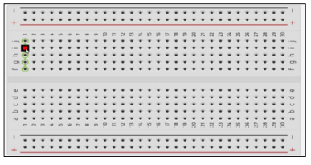

Terminal Strips

Power Rails

1. List the electronic components used in a circuit assembly
2. Resistors: Resistors are used to control the flow of current in a circuit. They are available in a wide variety of values and sizes.
3. Capacitors: Capacitors store energy in an electric field. They are used to filter noise, smooth out power supplies, and store energy for things like flash photography.
4. Inductors: Inductors store energy in a magnetic field. They are used in filters, oscillators, and power supplies.
5. Diodes: Diodes allow current to flow in one direction only. They are used to rectify AC voltage, protect circuits from reverse polarity, and switch current on and off.
6. Transistors: Transistors are used to amplify signals, switch current on and off, and control the flow of current in a circuit.
7. Integrated circuits (ICs): ICs are tiny chips that contain millions of transistors, resistors, and capacitors. They are used to perform a wide variety of functions, such as amplifying signals, processing data, and controlling devices.
8. LEDs: LEDs are light-emitting diodes that produce light when current flows through them. They are used in a wide variety of applications, such as displays, indicators, and lighting.
9. Switches: Switches are used to turn circuits on and off. They are available in a wide variety of types, such as pushbutton switches, toggle switches, and rotary switches.
10. Connectors: Connectors are used to connect electronic components to each other and to other devices. They are available in a wide variety of types, such as breadboard jumpers, banana jacks, and XLR connectors.